

# BrailleNote Touch 32 Plus 7.0 inches

## Type of device: Tablet

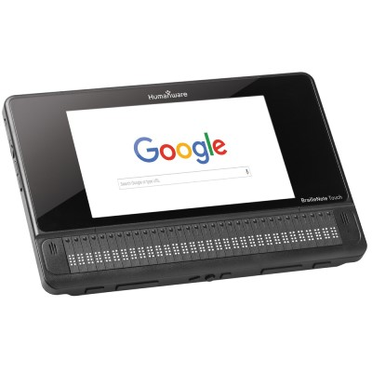

Actual Display Size : 7"

Operating System : Google Android

Version Number : 8.1

Year of Release : 2016

Average Price : $7495 as of 05 06 2020

Internet Access : Wi-Fi Only

## Accessibility Features:

### Cognitive

* Additional Instructions
* Copy and Paste
* Flicker Free Display
* GPS
* Photo Telephone List
* Screen Timeout Disabled
* Simple Instructions
* Simple Reminders
* Simplify Display

Voice Notes

### Hearing Impairment and Deaf

* Bluetooth or Wi-Fi
* Closed Captioning
* Vibrating Alerts - Adjustable

Visual Alerts - Incoming Calls

### Vision

* Accessibility APIs supported
* Battery Alert - Audible
* Bluetooth or Wi-Fi
* Braille Display Support
* Brightness Adjustable
* Dictation / Speech-to-Text
* Key Press - Vibration or Click
* Personalised Shortcuts
* Power Cue
* Screen Magnifier
* Screen Reader
* Text Size Adjustable
* Voice Control /Personal Assistant

Voiced Menus

### Speech

* Messaging Options - Email
* Messaging Options - IM

Predictive Text

### Physical

* Bluetooth or Wi-Fi
* Dictation / Speech-to-Text
* Flat Back for Table Top Operation
* Gesture Based Navigation
* Guarded/Recessed Keys
* Headset - plug connected
* Physical Dialling Keys
* Predictive Text
* Speaker-phone option
* Stylus or Prosthetic Device support
* Visible Focus Indicators
* Voice Control / Personal Assistant
* Voice Recognition for Accessing Features

Voice Recognition for Dialling

## How and where to get it from?

You can buy this tablet from [Humanware](https://store.humanware.com/hau/blindness-braillenote-touch-plus-32.html), [Vision Australia](https://shop.visionaustralia.org/shop/product/braillenote-touch-32-plus), and other retailers.

## More information is available on:

[BrailleNote Touch 32 Plus 7.0 inches Webpage](https://store.humanware.com/hau/blindness-braillenote-touch-plus-32.html)

[BrailleNote Touch 32 Plus 7.0 inches User Manual (PDF Download)](https://store.humanware.com/hau/blindness-braillenote-touch-plus-32.html)

[BrailleNote Touch 32 Plus 7.0 inches Support Webpage](http://support.humanware.com/en-australia/support/braillenote_touch/)

[BrailleNote Touch 32 Plus 7.0 inches YouTube Tutorial Videos](https://www.youtube.com/playlist?list=PLDWfRB9hDxLOuhwE_S9QvUjeOjSPEMesE)